Date : 2025/04/14
Name: Siron Prajapati
Semester 2, Level 3 Computing 'Section A '

- Write a program to count the number of lines, words, and characters in a text file.
Answer:
Code:
'''Write a program to count the number of
lines, words, and characters in a text file.'''

def count(files): #function to count
try:
with open(files,'r') as f: #opining file in read mode
word_count = 0
char_count = 0
lines_count = 0

for line in f:
lines_count +=1
char_count += len(line)
words = line.split()
word_count += len(words)

print("Output: \n")
print("The number of lines in the following files are",lines_count)
print("The number of words in the following files are",word_count)
print("The number of characters in the following files are",char_count)

except FileNotFoundError: #for error while finding file
print("File not Found!")

files = "program1.txt"
count(files)#call func.
Screenshot:
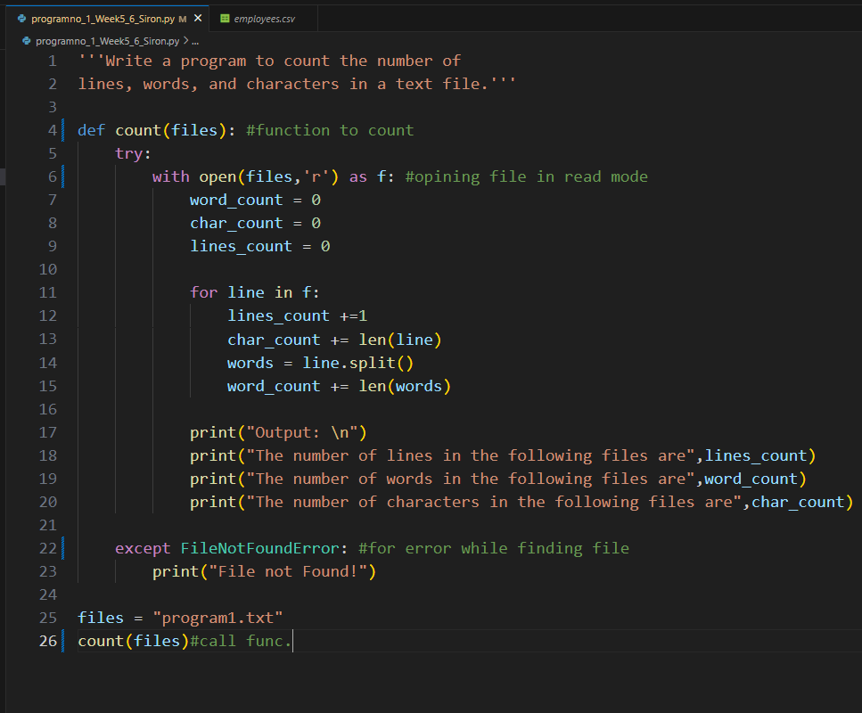
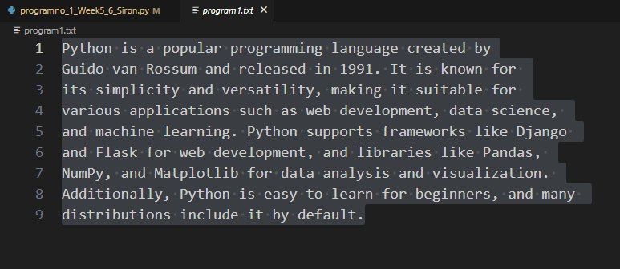

Output:
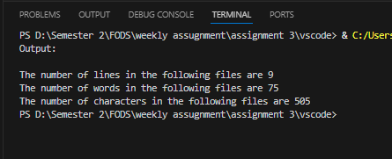

- Write a program to copy the contents of one file to another.
Answer:
'''Write a program to copy the contents of one file to another'''

with open("program1.txt",'r') as firstfile, open("program2.txt",'w') as secondfile:

for line in firstfile:
secondfile.write(line)

Screenshot:
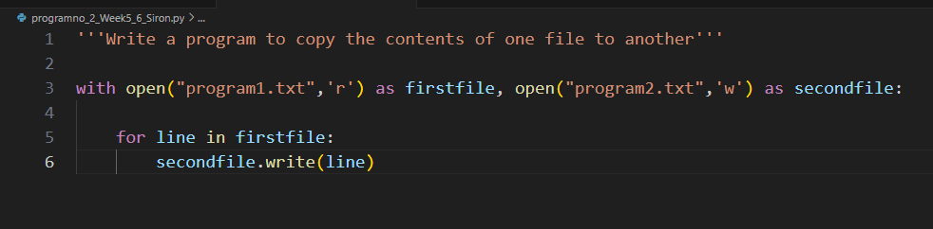

Output:
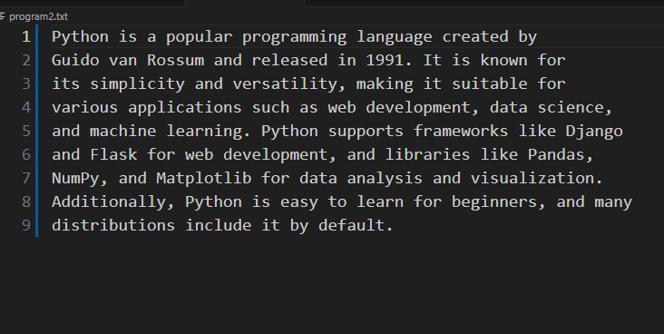

- Write a program to find and replace a specific word in a file with another word
Answer:
Code:
'''Write a program to find and replace
a specific word in a file with another word'''

find_word = "Python"
replace_word = "It"

with open("program3.txt",'r') as f:
data = f.read()
data = data.replace(find_word,replace_word)

with open("program3.txt",'w') as f:
f.write(data)

print("Word Replaced!")

Screenshot:
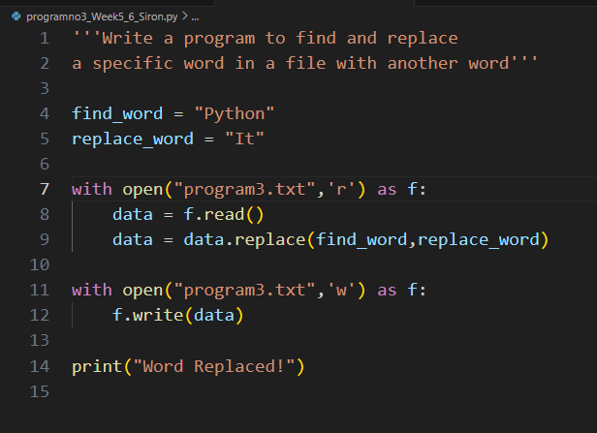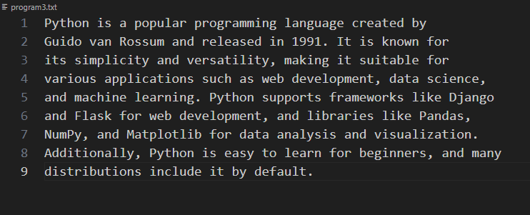

Output:
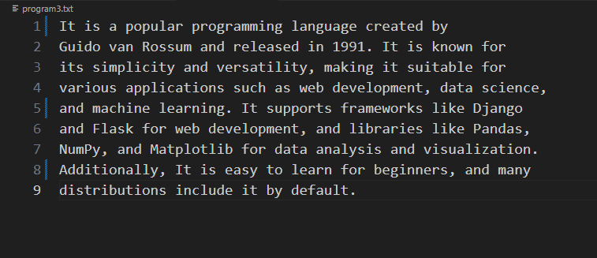

- Implement a program to read a CSV file and display its contents in a tabular format
Answer:
Code:
'''Implement a program to read a CSV file
and display its contents in a tabular format'''

import csv

f = ["Name","Year","GPA"]

r =[
["Siron","2008","3.71"],
["Sanita","2007","3.50"],
["Garima","2006","3.15"],
["Arika","2006","2.95"]
]

fn = "program4.csv"

with open(fn,'w',newline= '') as csvfile:
csv_content = csv.writer(csvfile)
csv_content.writerow(f)
csv_content.writerow(r)
Screenshot:
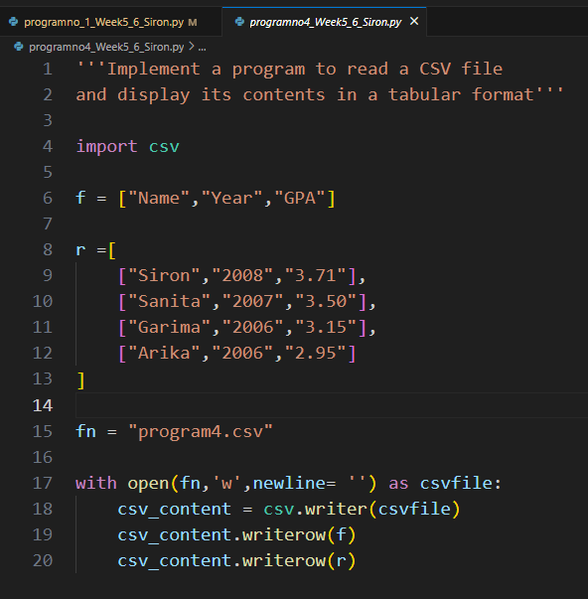

Output:
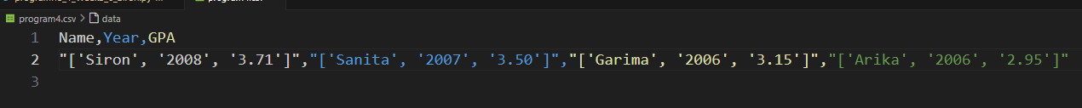

- Develop a program that counts the occurrence of each word in a file
Answer:
Code:
'''Develop a program that counts the occurrence of each word in a file.'''

text = open("program5.txt","r")
d=dict()

for line in text:
line = line.strip() #removing the spaces and newline characters
words = line.split(" ") #splitting the lines into words

for word in words:
if word in d:
d[word] = d[word] + 1

else:
d[word] = 1

for key in list(d.keys()):
print(key, ": ", d[key])

Screenshot:
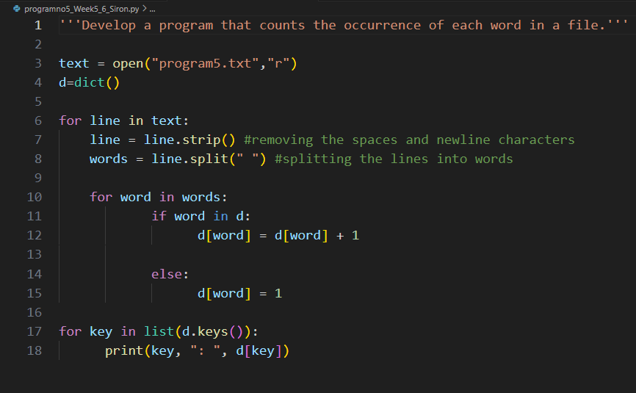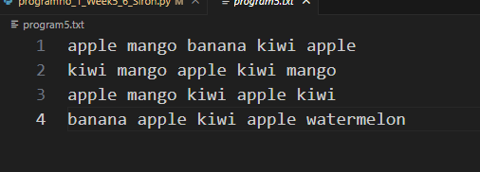
Output:
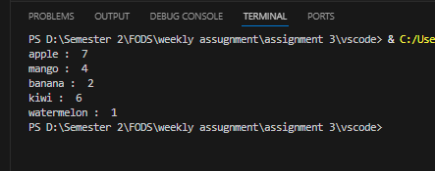

- Create a class Student with the attributes such as id, name, address, admission year, level, section. Instantiate the object of class to take input for all the attributes and display the output.
Answer:
Code:
'''Create a class Student with the attributes such as
id, name, address, admission year, level, section.
Instantiate the object of class to take input for
all the attributes and display the output. '''

class Student:
def __init__(self, student_id, name, address, admission_year, level, section):
self.student_id = student_id
self.name = name
self.address = address
self.admission_year = admission_year
self.level = level
self.section = section

def display_info(self):
print("\nStudent Details:")
print("ID:", self.student_id)
print("Name:", self.name)
print("Address:", self.address)
print("Admission Year:", self.admission_year)
print("Level:", self.level)
print("Section:", self.section)

def main():
print("Enter Student Details:")
student_id = input("Enter Student ID: ")
name = input("Enter Student Name: ")
address = input("Enter Student Address: ")
admission_year = input("Enter Admission Year: ")
level = input("Enter Level: ")
section = input("Enter Section: ")

student = Student(student_id, name, address, admission_year, level, section)
student.display_info()

main()

Screenshot:
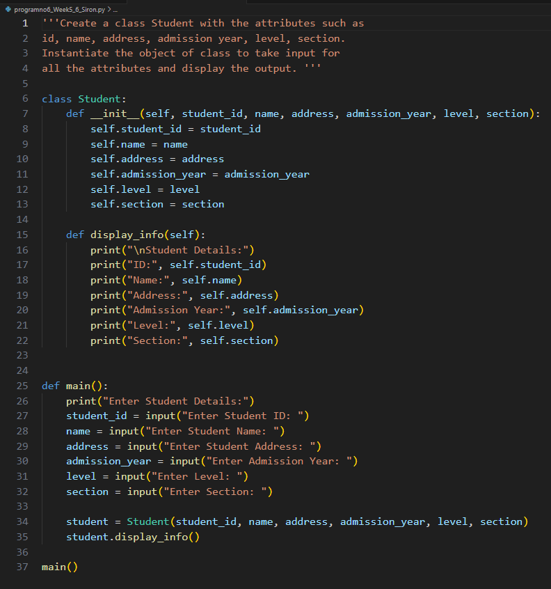

Output:
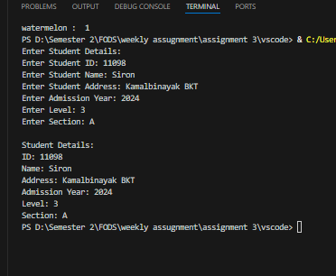

7.Write a program to implement a class called employee with attributes such as empid, name, address, contact_number, spouse name, number_of_child, salary. Instantiate this class to input the values for multiple employees and write it in a file “employees.csv”. Allow the user of your program to see the list of employees and their details as well. Try to use the concept of try/except too in the program.
Answer:
Code:
'''Write a program to implement a class called employee with
attributes such as empid, name, address, contact_number, spouse
name, number_of_child, salary. Instantiate this class to input
the values for multiple employees and write it in a file “employees.csv”.
Allow the user of your program to see the list of employees
and their details as well. Try to use the concept of
try/except too in the program.'''

import csv

# Define the Employee class
class Employee:
def _init_(self, empid, name, address, contact, spouse, children, salary): # Class Constructor
self.empid = empid
self.name = name
self.address = address
self.contact = contact
self.spouse = spouse
self.children = children
self.salary = salary

# Convert employee data to a list for writing to CSV
def to_list(self):
return [self.empid, self.name, self.address, self.contact, self.spouse, self.children, self.salary]

# Function to write employee data to a CSV file
def save_employees(employees):
try:
with open("employees.csv", "w", newline='') as file:
writer = csv.writer(file) # writer is a object jasle csv format ma store garxa data lai
# Write the header
writer.writerow(["EmpID", "Name", "Address", "Contact", "Spouse", "Children", "Salary"])
# Write employee data
for emp in employees:
writer.writerow(emp.to_list())
print("All employee data saved successfully.\n")
except Exception as e:
print("Error while saving:", e)

# Function to read and show employee data from the CSV file
def show_employees():
try:
with open("employees.csv", "r") as file:
reader = csv.reader(file) # reader is a object that reads every row as a list ie. list ma convert garxa euta row lai
next(reader) # Skip the header
print("\nEmployee Details:")
for row in reader:
print("ID:", row[0], "| Name:", row[1], "| Address:", row[2], "| Contact:", row[3],
"| Spouse:", row[4], "| Children:", row[5], "| Salary:", row[6])
except FileNotFoundError:
print("No employee data found. Please add employees first.\n")
except Exception as e:
print("Error while reading:", e)

# Main part of the program
def main():
employee_list = []

while True:
print("\nChoose an option:")
print("1. Add Employee")
print("2. Save & Show Employees")
print("3. Exit")
choice = input("Enter 1, 2, or 3: ")

if choice == "1":
# Input employee details from user
try:
empid = input("Enter Employee ID: ")
name = input("Enter Name: ")
address = input("Enter Address: ")
contact = input("Enter Contact Number: ")
spouse = input("Enter Spouse Name: ")
children = input("Enter Number of Children: ")
salary = input("Enter Salary: ")

# Create an employee object and add to the list
emp = Employee(empid, name, address, contact, spouse, children, salary)
employee_list.append(emp)
print("Employee added.\n")
except Exception as e:
print("Something went wrong:", e)

elif choice == "2":
save_employees(employee_list)
show_employees()

elif choice == "3":
print("Goodbye!")
break

else:
print("Invalid option. Try again.")

# Run the main function
main()

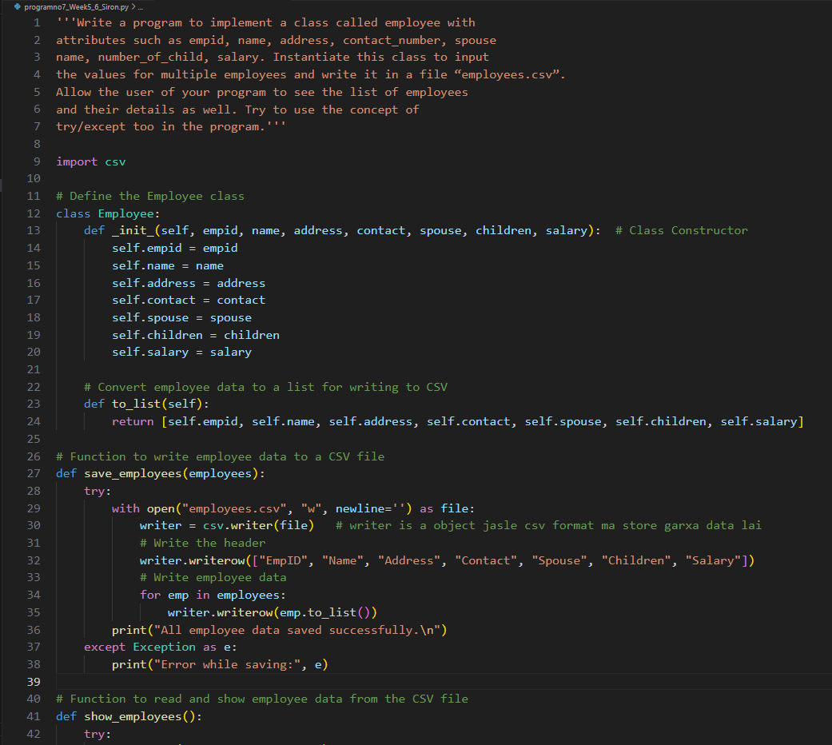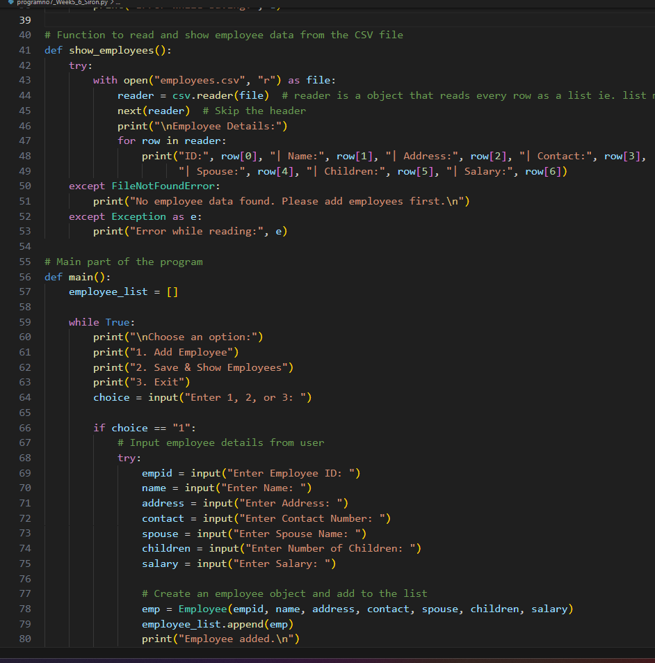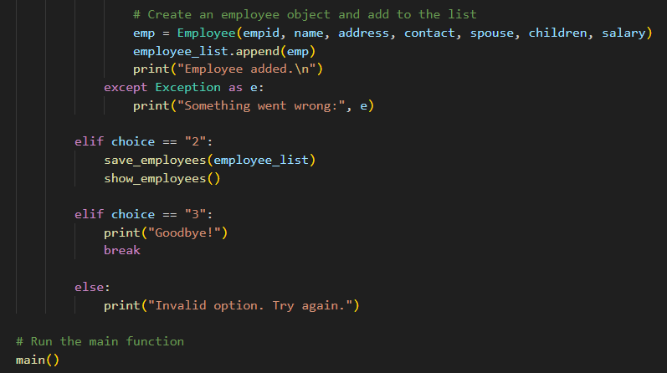

Output:
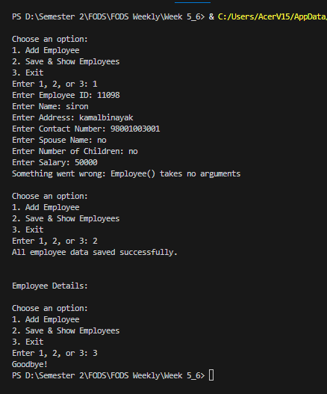

8.Write a program to implement a basic library book management with the functionalities such as issue the book, return the book and search the book. Use the concept of OOP to create the necessary classes on your own and implement the concept of other OOP features. For the storage of book details, use the file handling along with the exception handling.
Answer:
Code:
'''Write a program to implement a basic library book management with the functionalities such as issue the book, return the book
and search the book. Use the concept of OOP to create the necessary classes on your own and implement the concept of other OOP features.
For the storage of book details, use the file handling along with the exception handling. '''

class Book:
def __init__(self, book_id, title, issued=False):
self.book_id = book_id # Unique identifier for the book
self.title = title # Title of the book
self.issued = issued # Status: True if issued, False if available

# Converts book details into a line of text for saving into a file
def to_line(self):
return f"{self.book_id}|{self.title}|{self.issued}"

# Creates a Book object from a line of text from the file
@staticmethod
def from_line(line):
parts = line.strip().split("|")
return Book(parts[0], parts[1], parts[2] == "True")

# Class representing the entire library
class Library:
def __init__(self):
self.books = [] # List to store all books
self.filename = "library.txt" # File to save and load books
self.load_books() # Load books from file on startup

# Load book data from the file
def load_books(self):
try:
with open(self.filename, "r") as f:
for line in f:
book = Book.from_line(line)
self.books.append(book)
except FileNotFoundError:
print("No existing library file found. Starting fresh.")
except Exception as e:
print("Error reading file:", e)

# Save all book data to the file
def save_books(self):
try:
with open(self.filename, "w") as f:
for book in self.books:
f.write(book.to_line() + "\n")
except Exception as e:
print("Error writing file:", e)

# Add a new book to the library
def add_book(self):
book_id = input("Enter new Book ID: ")
title = input("Enter Book Title: ")

# Check if Book ID already exists
for book in self.books:
if book.book_id == book_id:
print("Book ID already exists.")
return

self.books.append(Book(book_id, title))
print("Book added successfully.")

# Display all books in the library
def view_all_books(self):
if not self.books:
print("No books in library.")
return

print("\nLibrary Books:")
for book in self.books:
status = "Issued" if book.issued else "Available"
print(f"{book.book_id} - {book.title} ({status})")

# Mark a book as issued
def issue_book(self):
book_id = input("Enter Book ID to issue: ")
for book in self.books:
if book.book_id == book_id:
if not book.issued:
book.issued = True
print("Book issued.")
else:
print("Book already issued.")
return
print("Book not found.")

# Mark a book as returned
def return_book(self):
book_id = input("Enter Book ID to return: ")
for book in self.books:
if book.book_id == book_id:
if book.issued:
book.issued = False
print("Book returned.")
else:
print("Book was not issued.")
return
print("Book not found.")

# Search for a book by a keyword in its title
def search_book(self):
keyword = input("Enter keyword to search: ").lower()
found = False
for book in self.books:
if keyword in book.title.lower():
status = "Issued" if book.issued else "Available"
print(f"{book.book_id} - {book.title} ({status})")
found = True
if not found:
print("No matching book found.")

# Main function to run the menu and interact with the library
def main():
lib = Library()

while True:
print("\n--- Library Menu ---")
print("1. Add New Book")
print("2. View All Books")
print("3. Issue Book")
print("4. Return Book")
print("5. Search Book")
print("6. Exit")
choice = input("Choose option: ")

if choice == "1":
lib.add_book()
elif choice == "2":
lib.view_all_books()
elif choice == "3":
lib.issue_book()
elif choice == "4":
lib.return_book()
elif choice == "5":
lib.search_book()
elif choice == "6":
lib.save_books()
print("Data saved. Goodbye!")
break
else:
print("Invalid choice.")

main()

Screenshot:
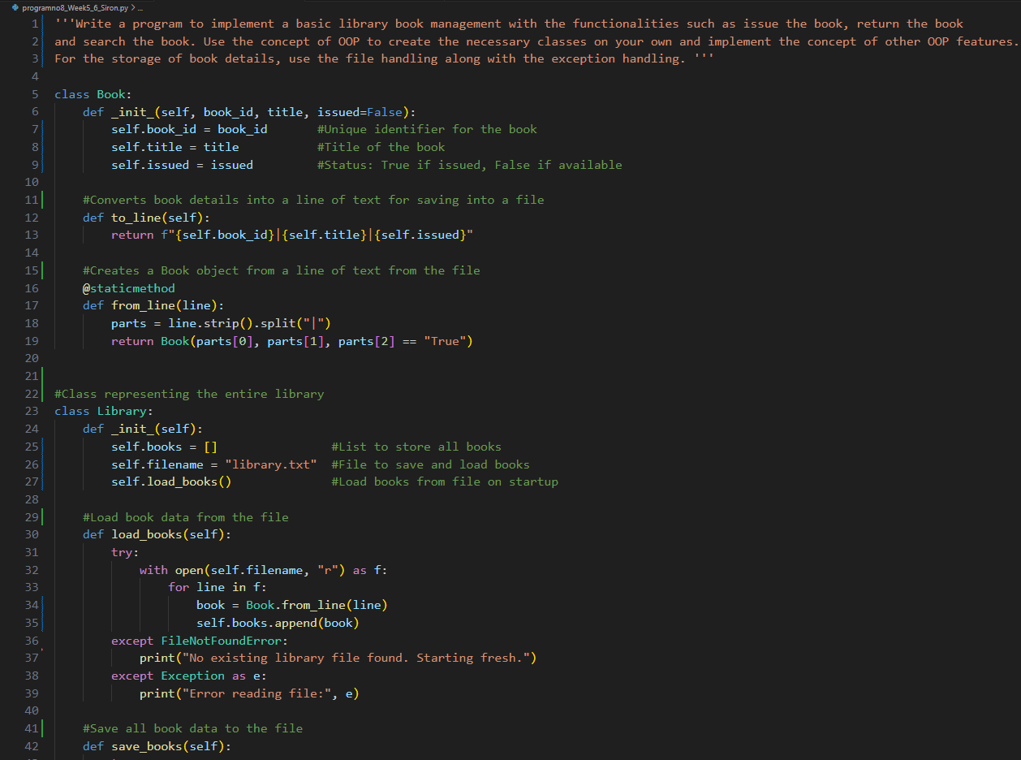
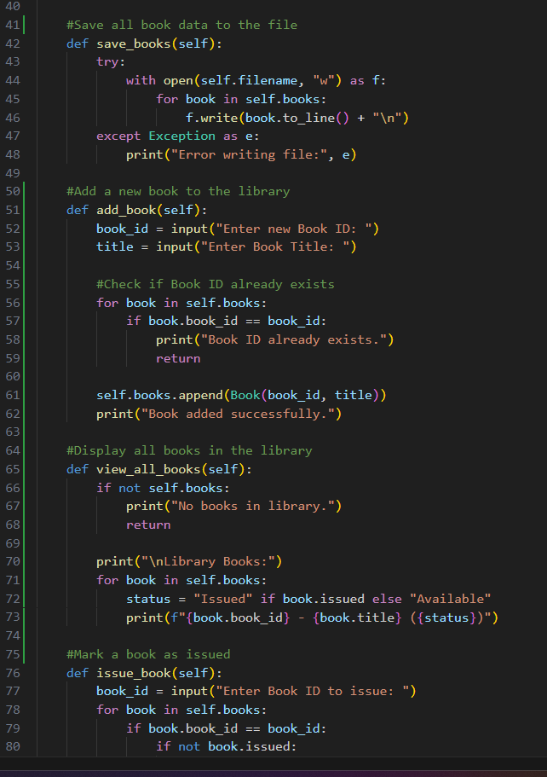
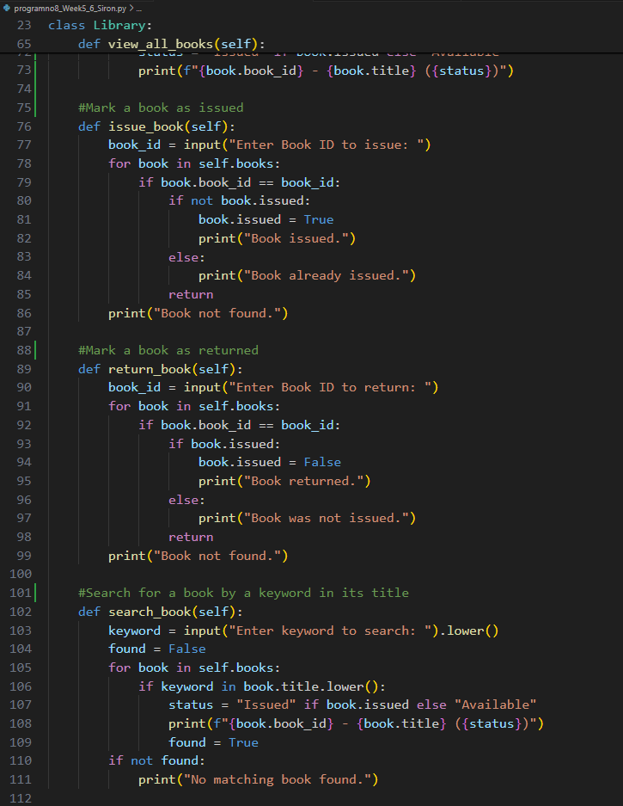
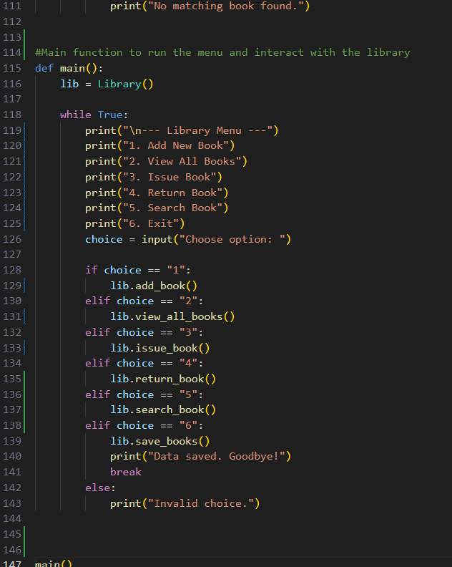

Output:
